Report template

Introduction to DevOps
Practical Assignment

Name: LuLu
Email (associated with Moodle): Lu.Lu@student.lut.fi

- Describe how you improved the DevOps environment at company X regarding the following aspects.

  - Version control (explain how you solved the merge conflict)
In this practical assignment, Git was used as the version control system to manage project changes and collaborate efficiently.Git Configuration: I initialized the environment by configuring the global user identity to track contributions accurately, using commands such as:
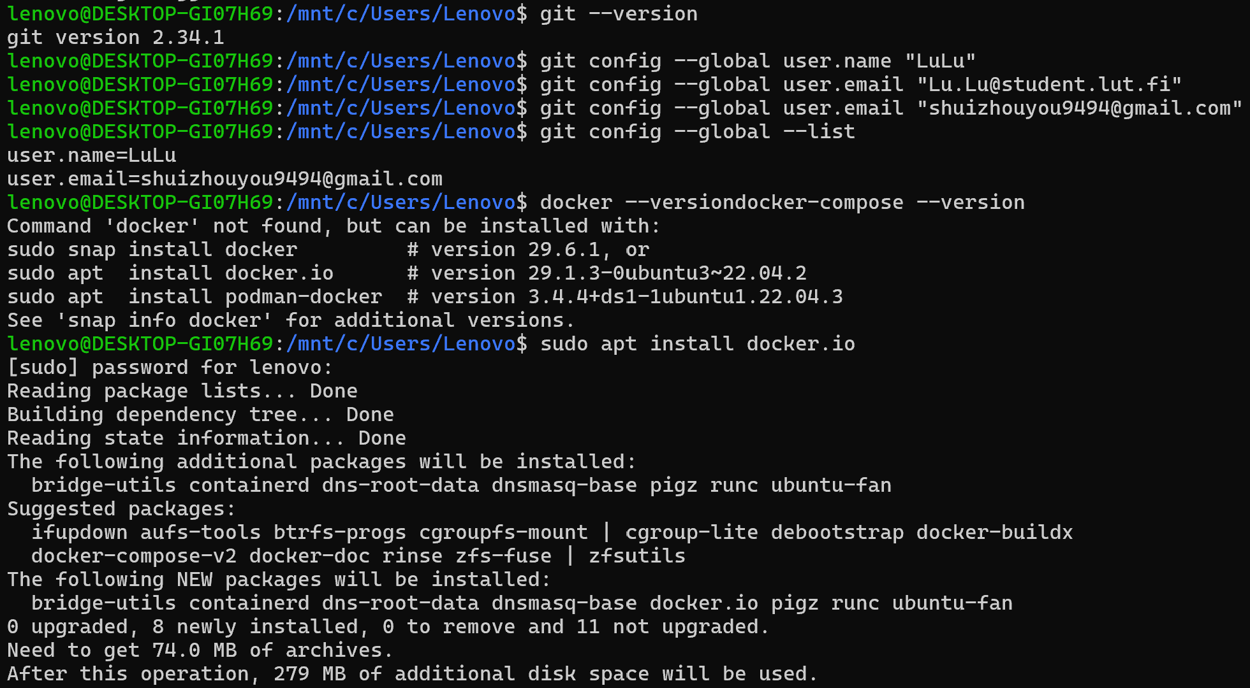
Handling and Resolving Merge Conflicts: During the merging of different branches, a merge conflict occurred when concurrent modifications was made to the same lines of a file. The conflict was resolved using the following structured approach:
Identification: Git flagged the conflicted files during the merge process, and I used git status to identify them.
Manual Resolution: I opened the affected files and inspected the conflict markers (<<<<<<<, =======, >>>>>>>) inserted by Git to compare the competing changes from different branches.
Selection and Editing: I manually edited the code to keep the required changes and remove the conflict markers.
Finalization: After resolving the discrepancies, I staged the resolved files using git add <file> and completed the merge process by committing the changes.

  - Software containerization (how did you modify the Dockerfile?)
In this practical assignment, software containerization was implemented to ensure the application runs consistently across different environments.
Base Image and Dockerfile Setup: We started by defining the application's environment and dependencies using a Dockerfile. For this practical task, we utilized and tested with standard container images (such as docker/getting-started) to understand the core lifecycle of images and containers.
Port Management and Troubleshooting: During the execution phase using the Docker CLI (docker run), we encountered port conflict issues where host ports (such as 80 and 8080) were already allocated by other services. This was resolved by re-mapping the container to an available host port (e.g., mapping port 9090 to the container's internal port 80 using -p 9090:80).
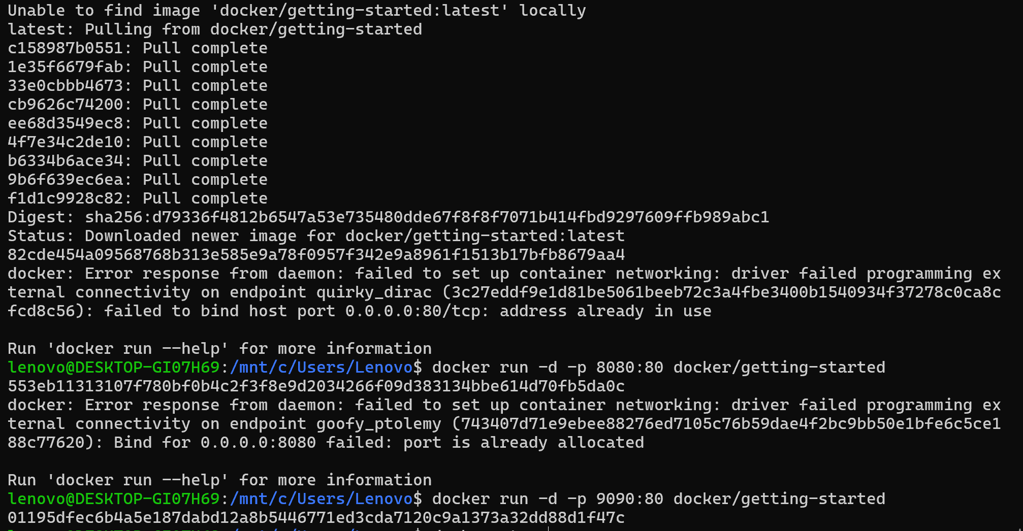
Container Lifecycle Management: We practiced managing the container lifecycle by utilizing commands such as docker ps to monitor active instances, docker stop to gracefully halt running containers, and docker rm to clean up resources and free up system ports.
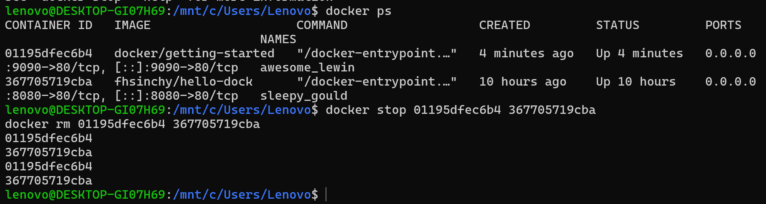

  - Cloud environment (how did you create and configure the cloud service?)

Created an Azure App Service (Web App) named lu-app-2026 using the Azure Portal under an Azure for Students subscription.

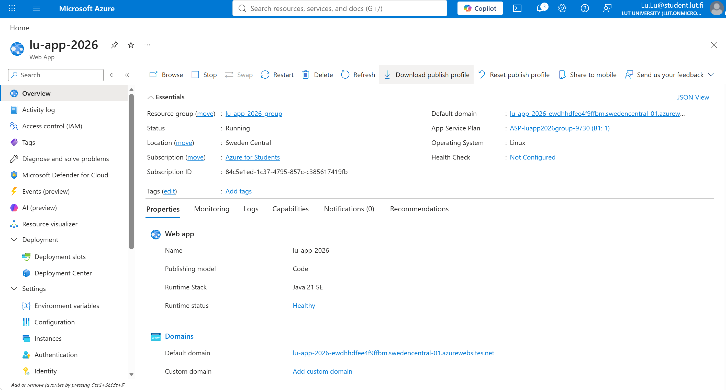

Configured the hosting environment with Linux as the operating system and enabled necessary stack configurations.

Enabled SCM Basic Auth Publishing Credentials in the Web App configuration settings to allow external deployment tools to authenticate securely and obtain the required publish profile.

  - CI / CD pipeline (how did you modify the .gitlab-ci.yml?)

Publish Profile Secret: Downloaded the Web App's publish profile from Azure and stored it securely as a repository secret (AZURE_WEBAPP_PUBLISH_PROFILE) in GitHub Settings.

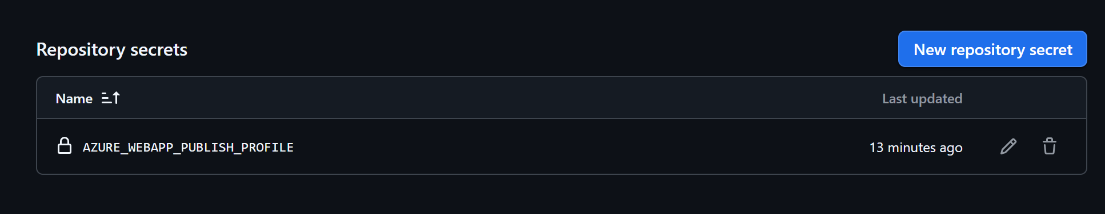

Workflow Configuration: Created a custom workflow file (equivalent to CI/CD pipeline configuration, stored under .github/workflows/deploy.yml) to handle automated deployment.
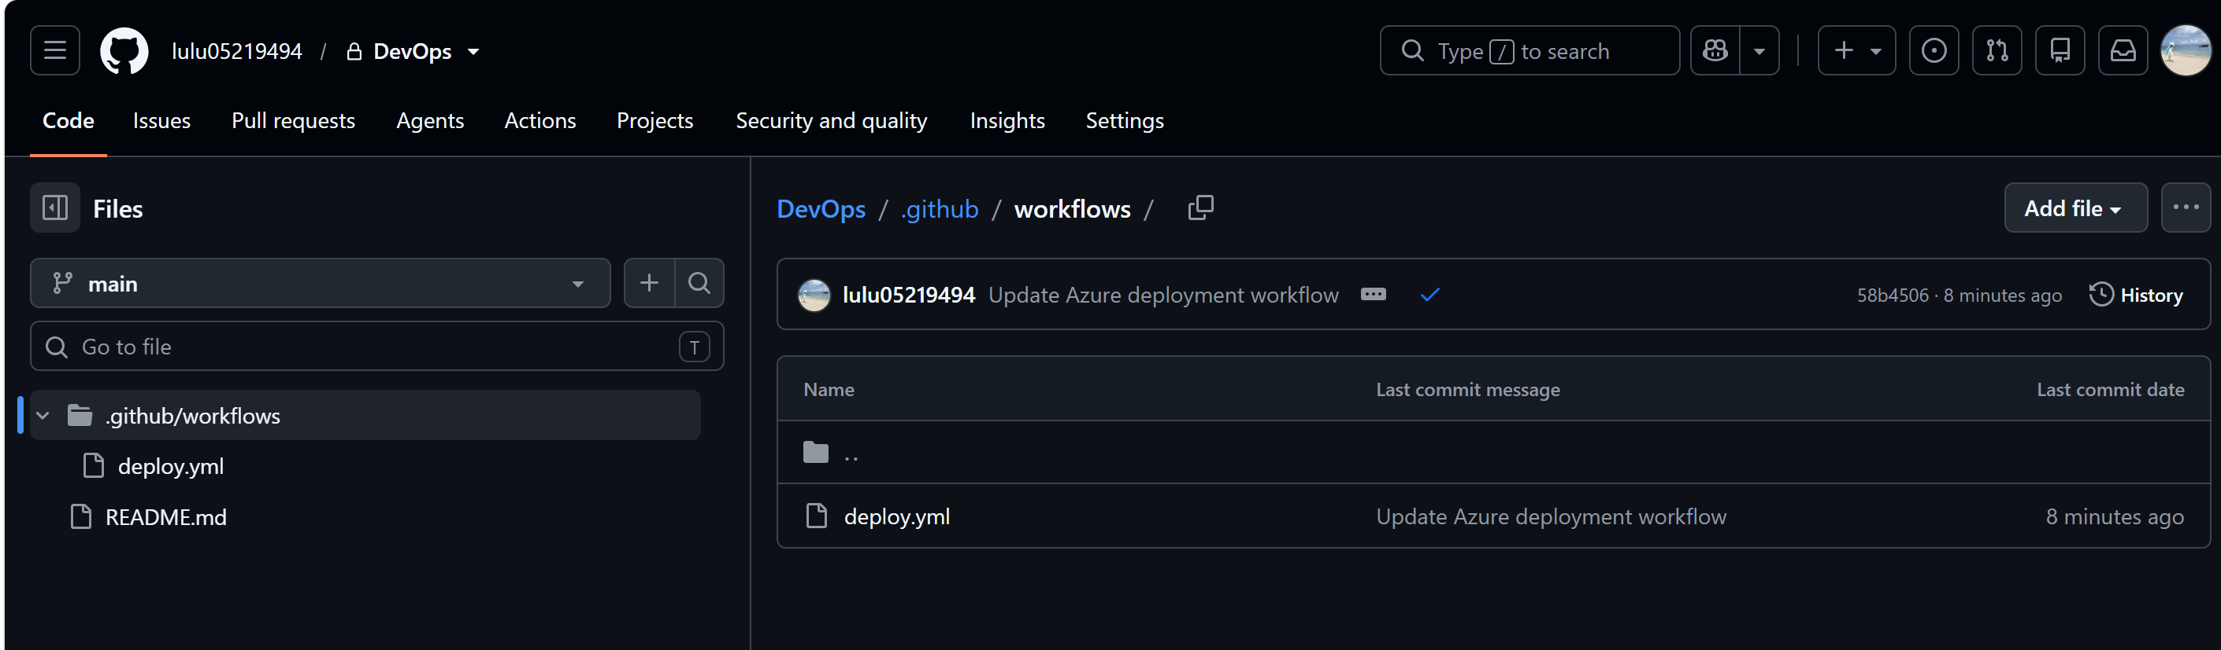

Trigger: Configured the pipeline to trigger automatically on every push event to the main branch.

Checkout & Deploy: Utilized the official actions/checkout to fetch the repository code and the azure/webapps-deploy action to securely deploy the application package to the Azure Web App using the stored publish profile secret.

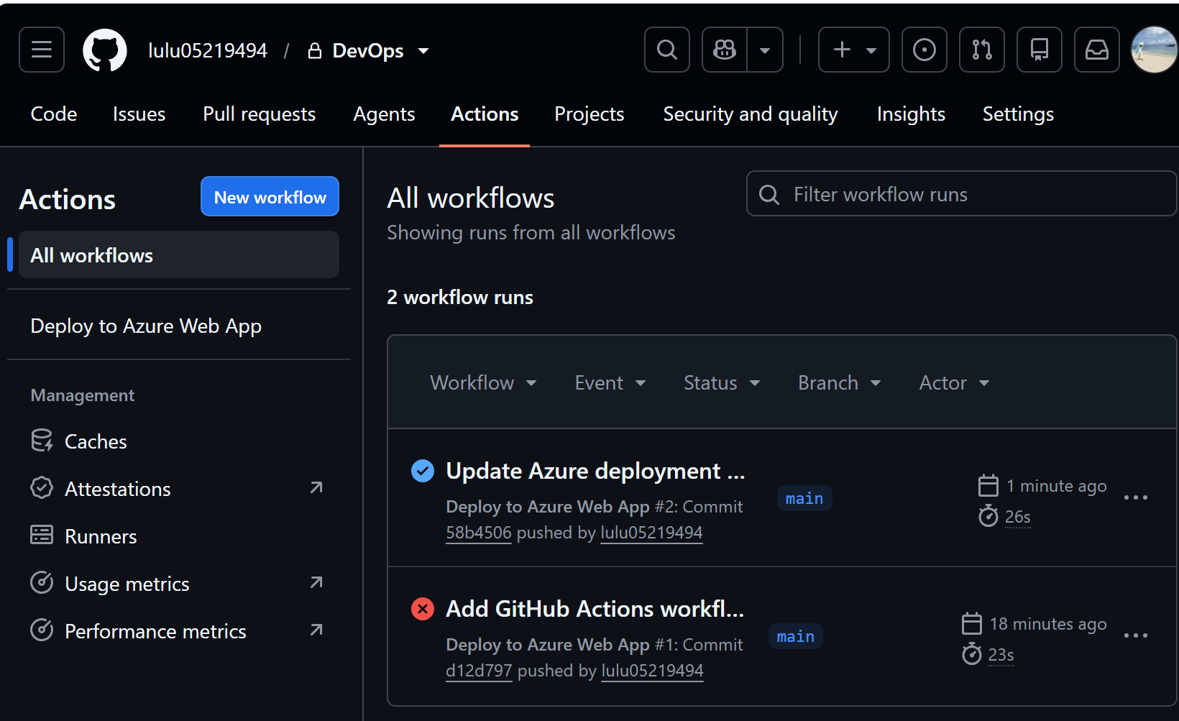

- Provide a process model illustrating the created CI / CD pipeline. (You may use UML, eg. An activity diagram. You can use this tool to create the model).

